AR Module Implementation Project
Microsoft Dynamics 365 Finance & Operations

Creating Legal Entity
Navigate to:
Organization administration → Organizations → Legal entities
- Click on New
- A dialog box will appear
Fill in the following fields:
- Name: Full legal entity name
- Company: Short company code
- Country/Region: Select country
- Click OK
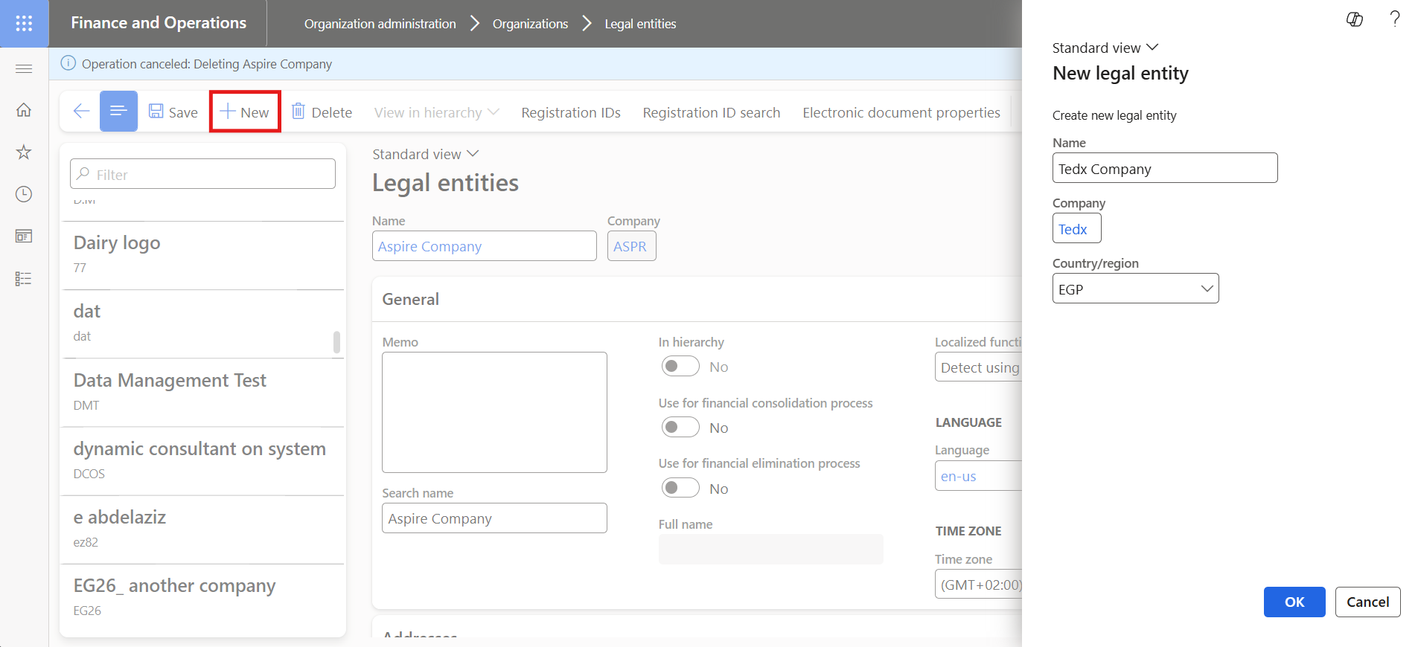
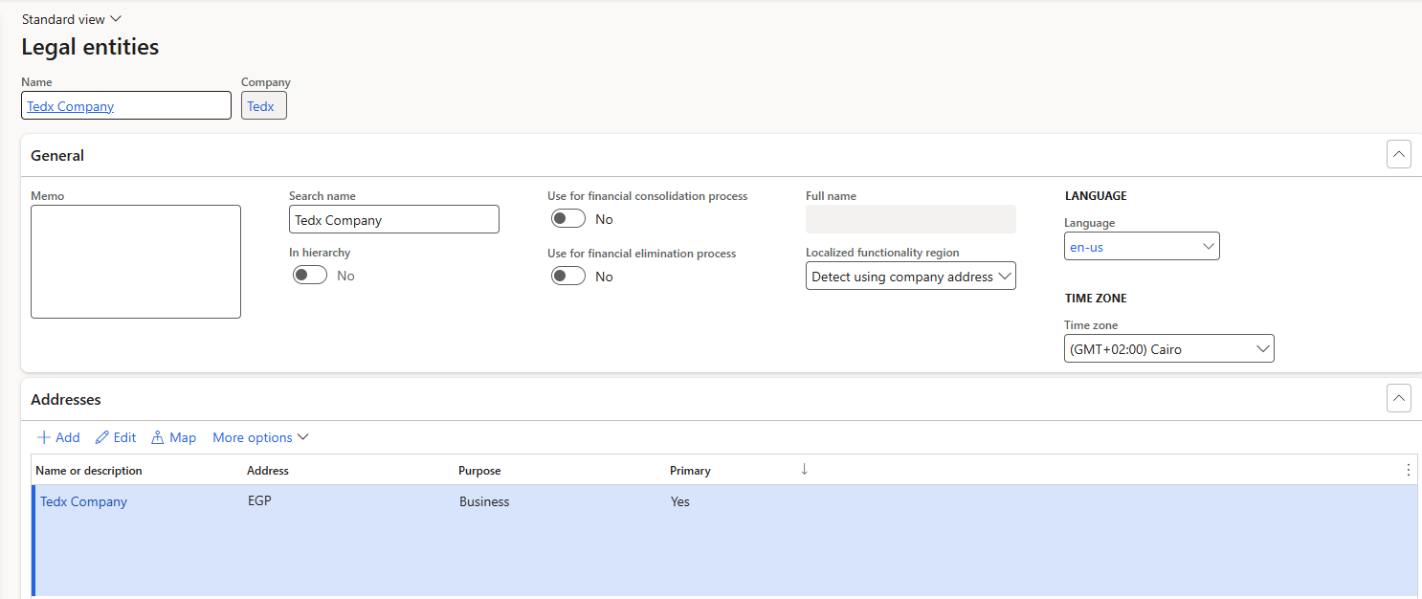

Creating Chart of Accounts
Navigate to:
General ledger → Chart of accounts → Accounts → Chart of accounts
- Click New
Fill in:
- Main Account: Enter account number
- Name: Enter account name
- Main Account Type: Select type
- Main Account Category: Select category
- Click Save
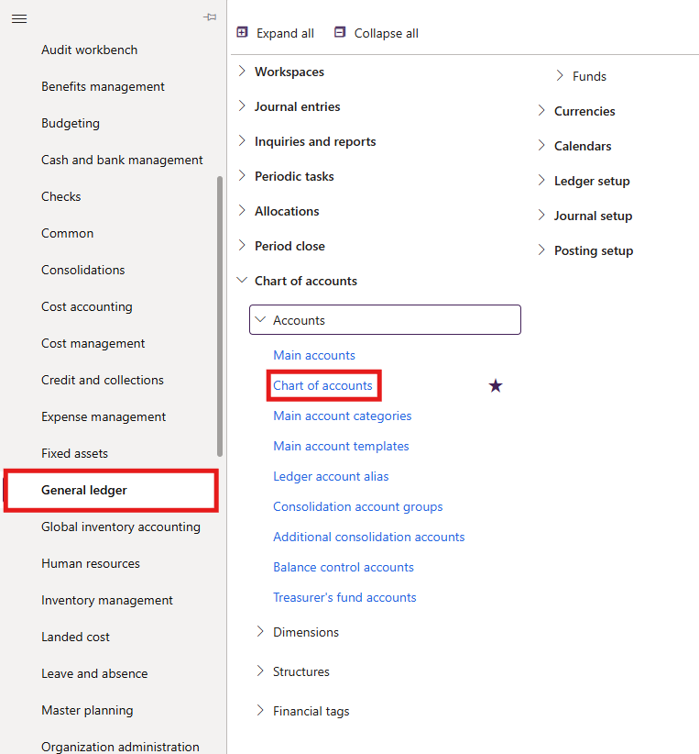
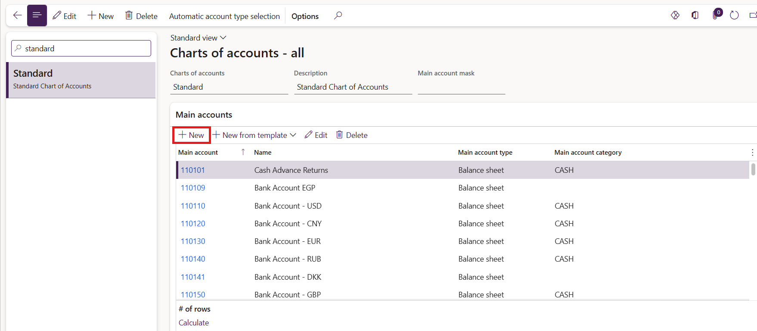

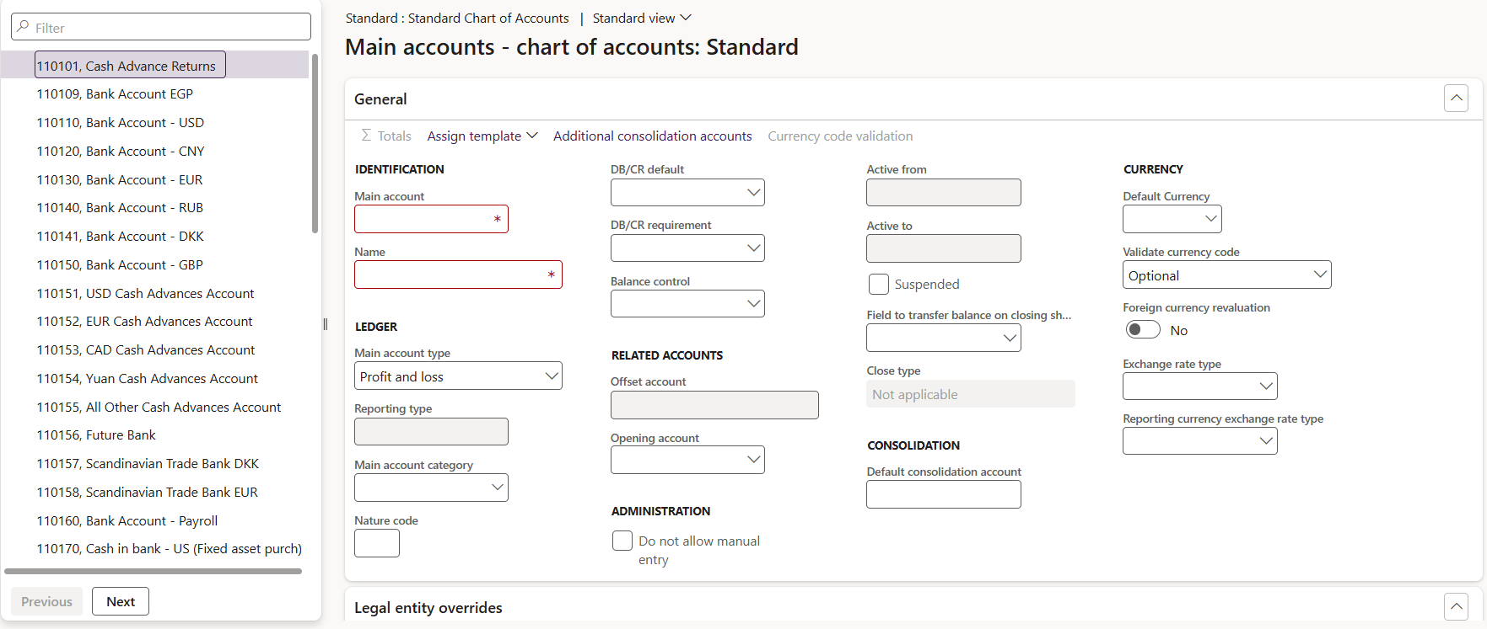

Creating Fiscal Calendar
Navigate to:
General ledger → Calendars → Fiscal calendars
- Click New Calendar
- Enter calendar name
- Click Create
Set:
- Start Date: 01/012026/
- End Date: 31/12/ 2026
- Click Save
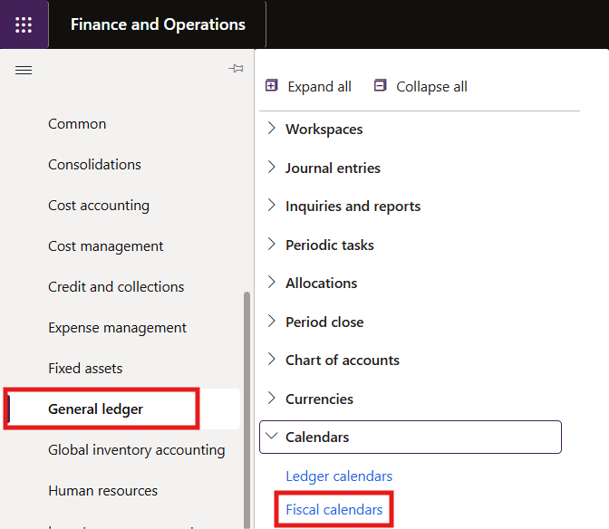
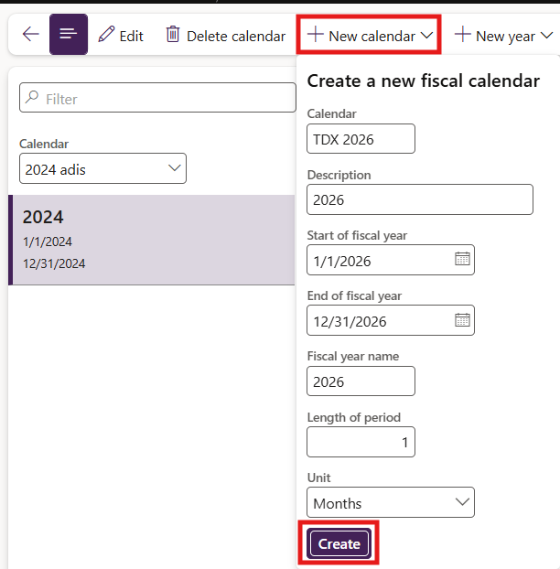

Creating Account Structure
Navigate to:
General ledger → Chart of accounts → Structures → Configure account structures
- Click New
- Enter structure name
- Select Main Account
- Add financial dimensions (if needed)
- Click Activate
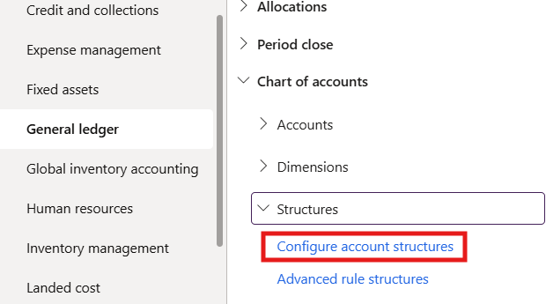
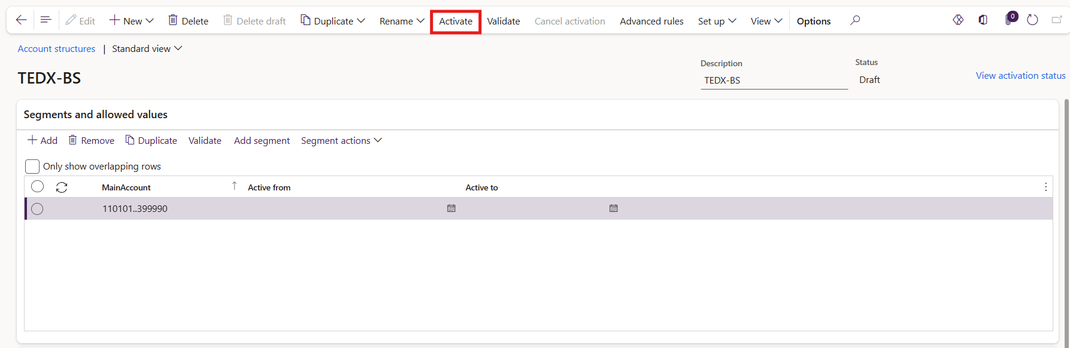

Ledger Configuration
Navigate to:
General ledger → Ledger setup → Ledger
- Select ledger
- Set Accounting currency
- Assigning Account Structure
- Click Save

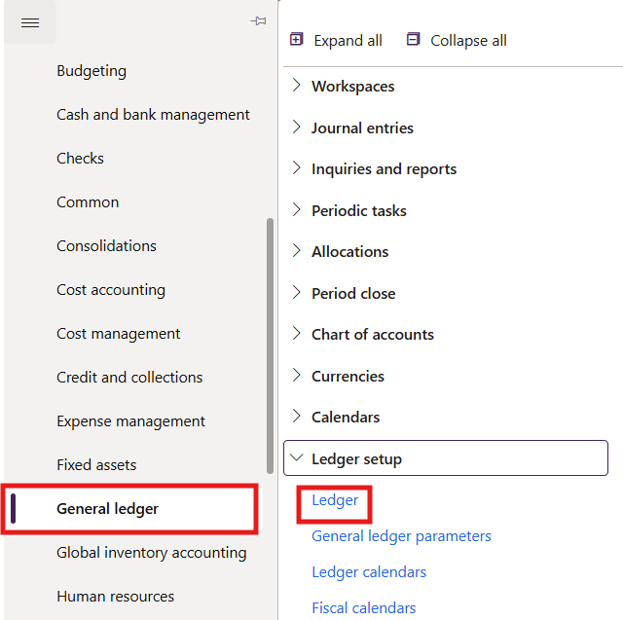
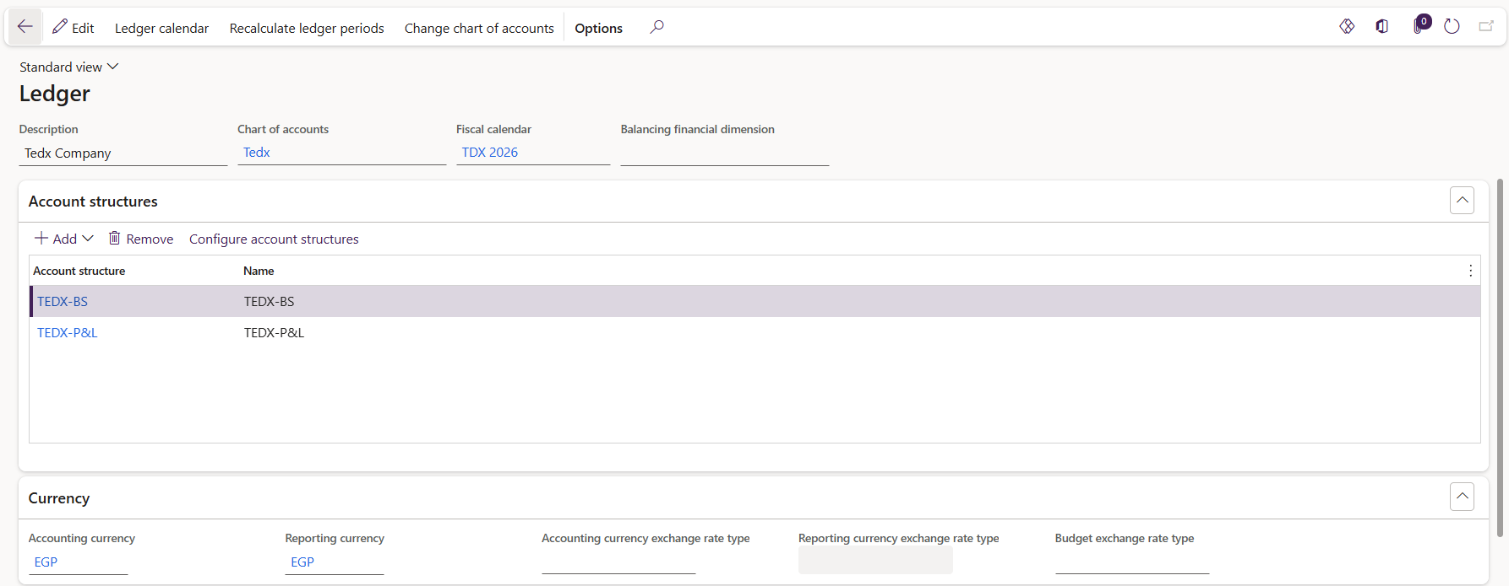

Creating Customer Groups
Navigate to:
Accounts receivable → Setup → Customer groups
- Click New
- Enter Customer Group
- Enter Description
- Click Save
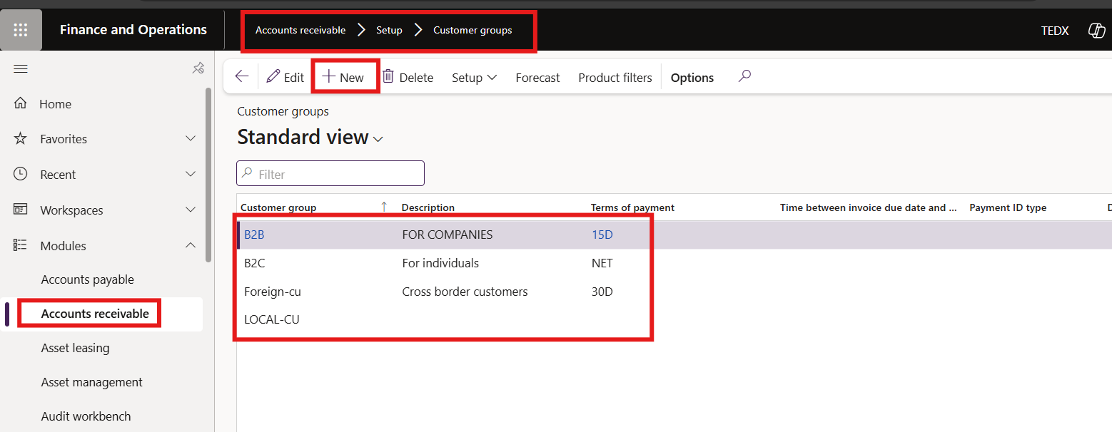

Creating Payment Terms
Navigate to:
Accounts receivable → Setup → Payment → Payment terms
- Click New
- Enter Name (Net30)
- Enter Days = 30
- Click Save
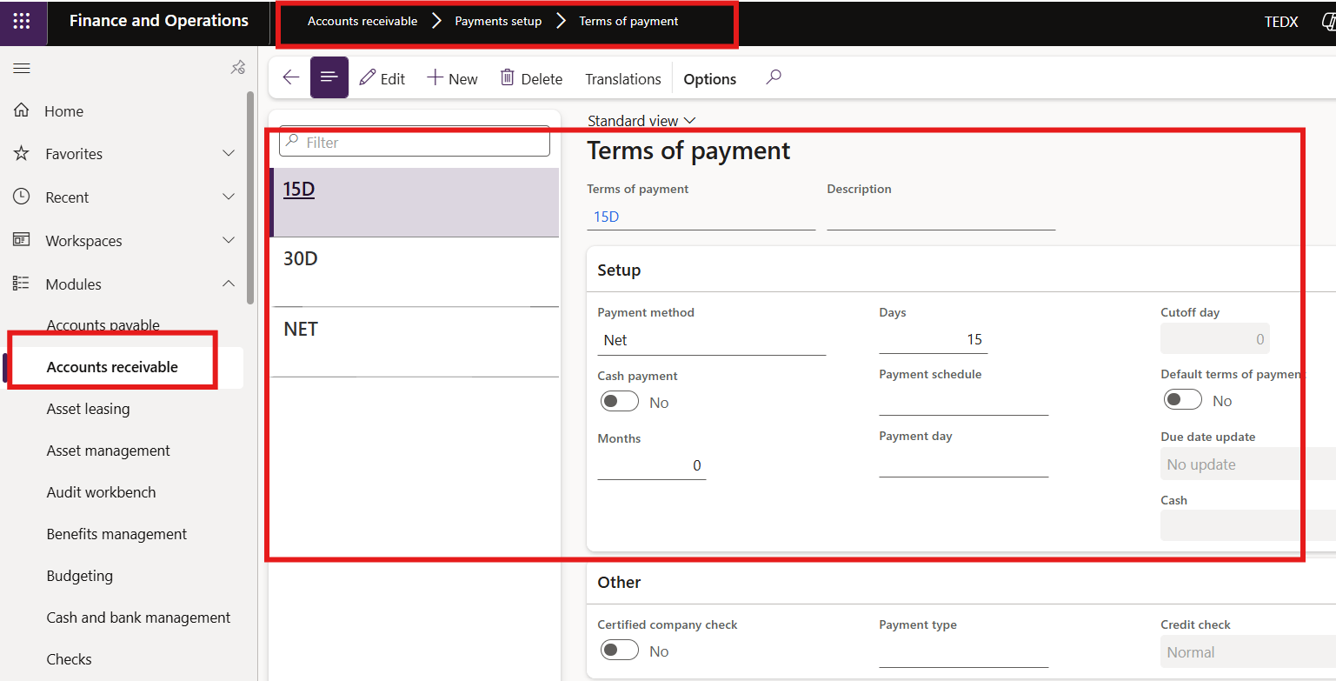

Creating Posting Profile
Navigate to:
Accounts receivable → Setup → Customer posting profiles
- Click New
- Enter Posting Profile
- In Table section:
  - Click New
  - Select Customer Group
  - Assigning AR Account
- Click Save
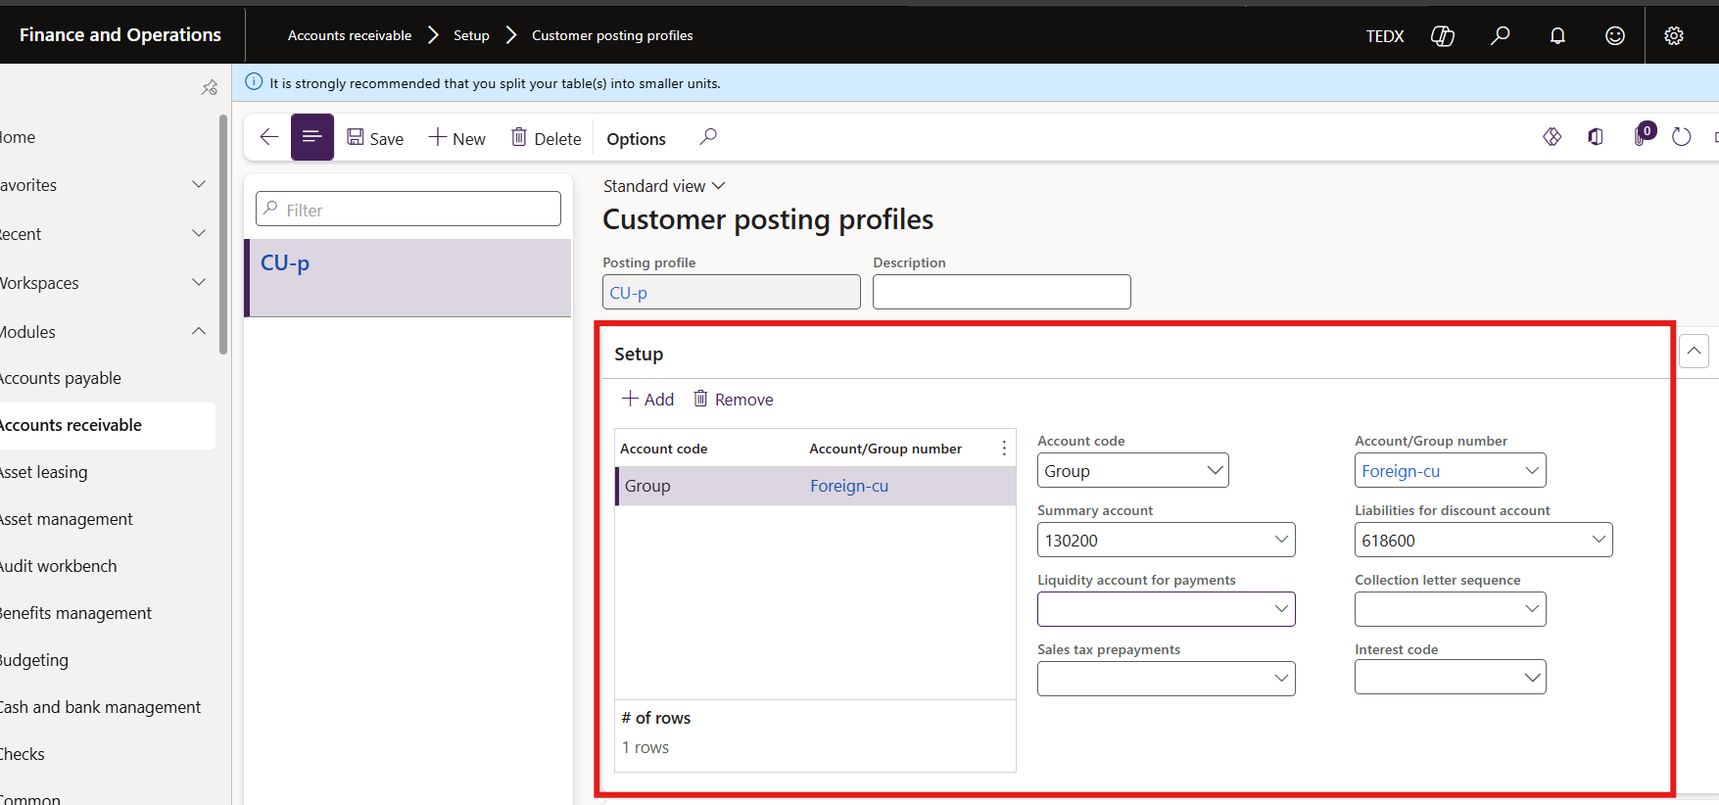

Creating Number Sequences
Navigate to:
Organization administration → Number sequences → Number sequences
- Click New
- Define sequence (Customer / Invoice / Voucher)
- Click Save
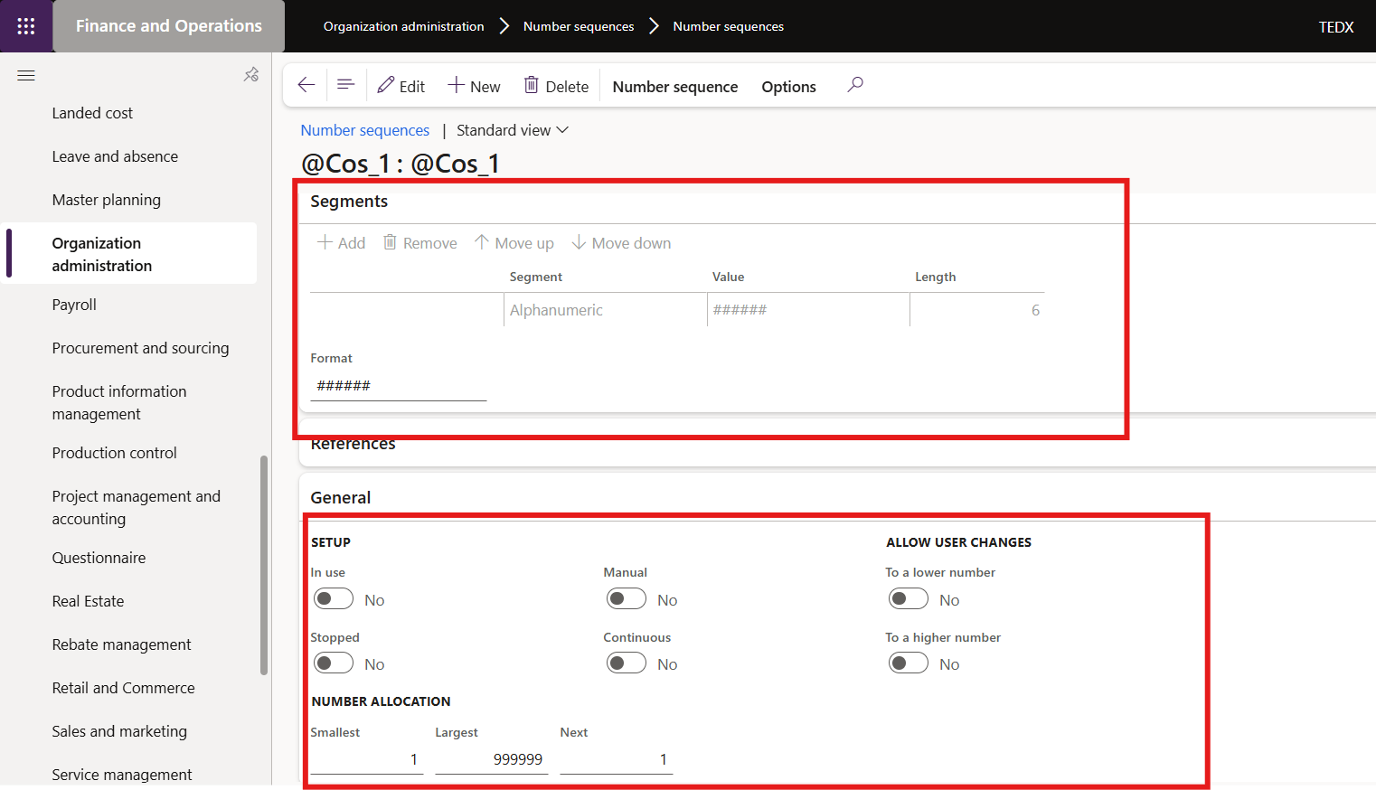
Then assign:
Accounts receivable → Setup → AR parameters → Number sequences tab
- Assign sequences
- Click Save
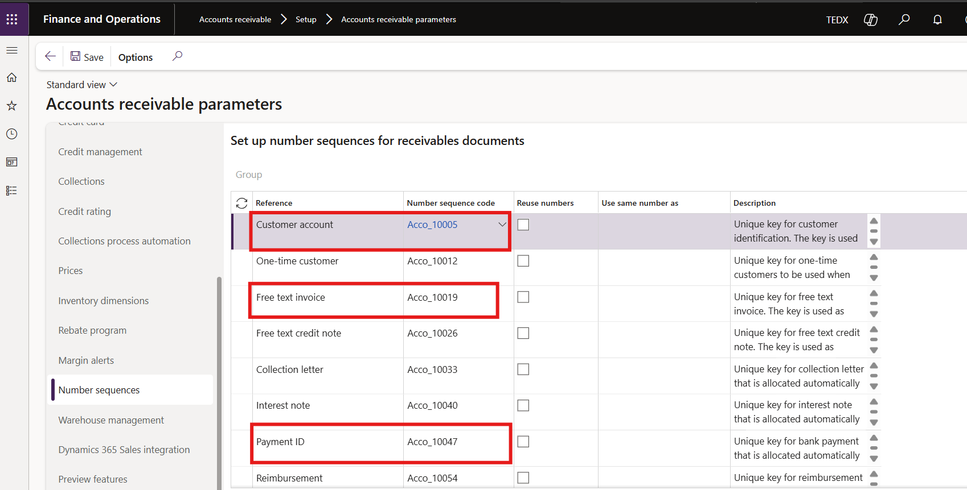

Creating Bank Ledger (Bank Account Setup)
Navigate to:
Cash and bank management → Bank accounts → Bank accounts

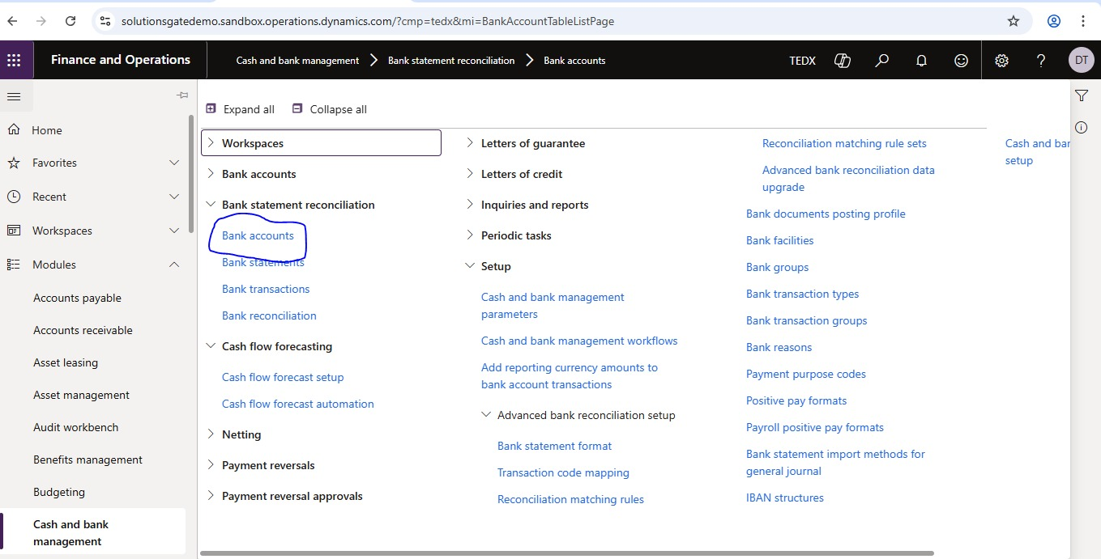

Step 1: Create Bank Account
- Click on New
A new form will open
Fill in the following fields:
- Bank Account: Enter bank ID (e.g., BANK_EGP)
- Name: Enter bank name (e.g., Main Bank Account)
- Bank Group: Select bank group (or create one if not available)
- Currency: Select currency (e.g., EGP / USD)
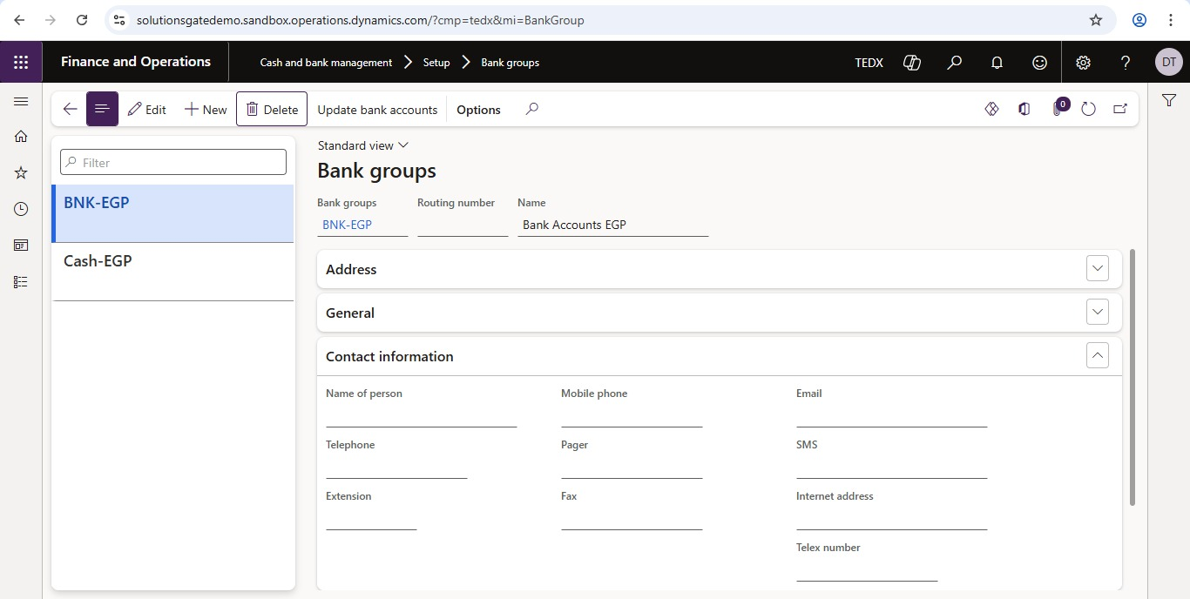

Assigning Ledger Account
Scroll down to the General section
Fill in:
- Main Account: Select Bank GL Account (from Chart of Accounts)
This account will be used when recording payments
Click on save

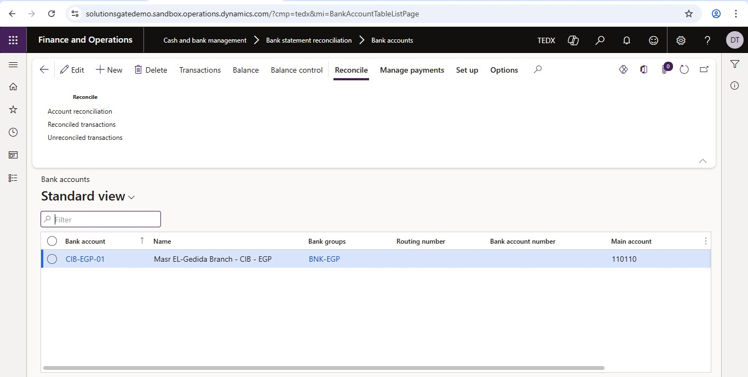

Linking Bank in Payment Journal
Navigate to:
Accounts receivable → Payments → Customer payment journal

- Click New
- Select Journal Name
- Click Lines
Fill in:
- Account Type: Customer
- Account: Select customer
- Offset Account Type: Bank
- Offset Account: Select Bank Account
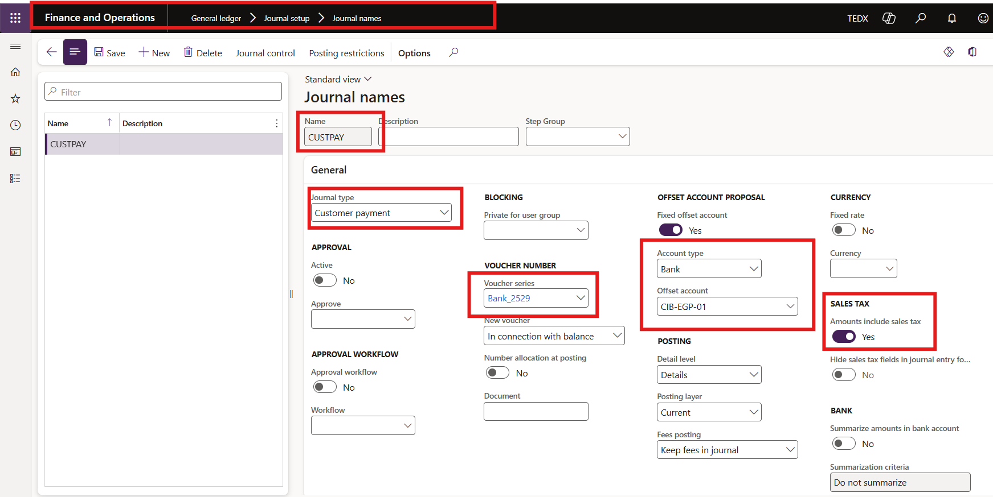

Creating Customer
Navigate to:
Accounts receivable → Customers → All customers
- Click New
Fill in:
- Customer Account
- Name
- Customer Group
- Currency
Invoice and Delivery Tab:
- Payment Terms
- Click Save
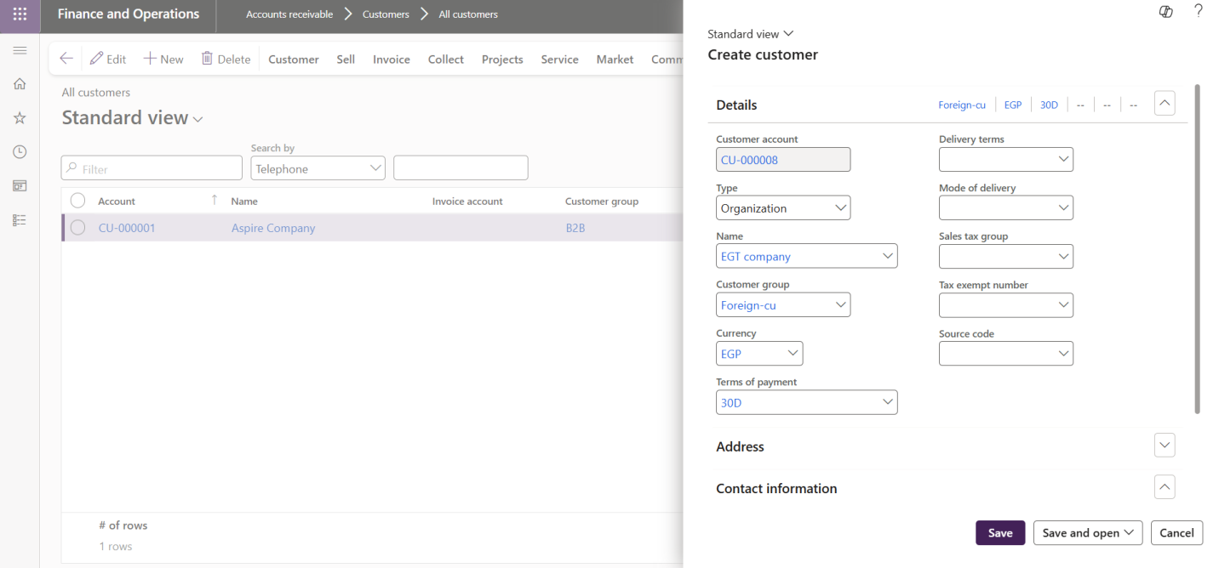

Creating Sales Order
Navigate to:
Accounts receivable → Orders → All sales orders
- Click New
- Select Customer
- Click OK
- Click Add line
Fill in:
- Item Number
- Quantity
- Unit Price
- Click Save
- Click:
Sell → Confirm Sales Order
- Click OK
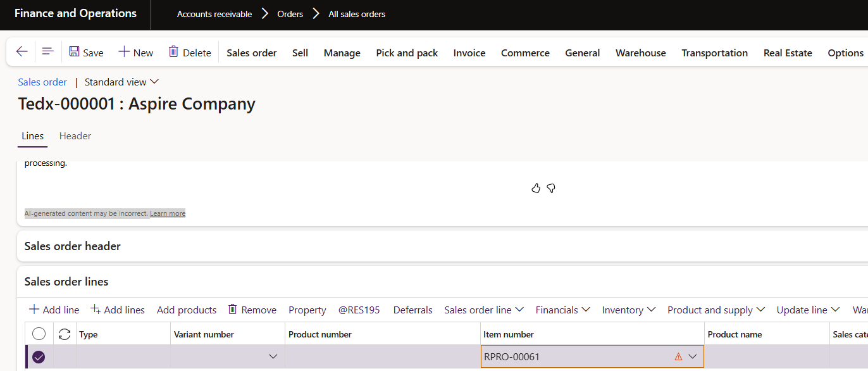

Delivery (Packing Slip)
- Click: Sell → Packing Slip
- Click OK

Invoice Posting
- Click: Sell → Invoice
- Click OK
Accounting Entry:
Dr Accounts Receivable
Cr Revenue

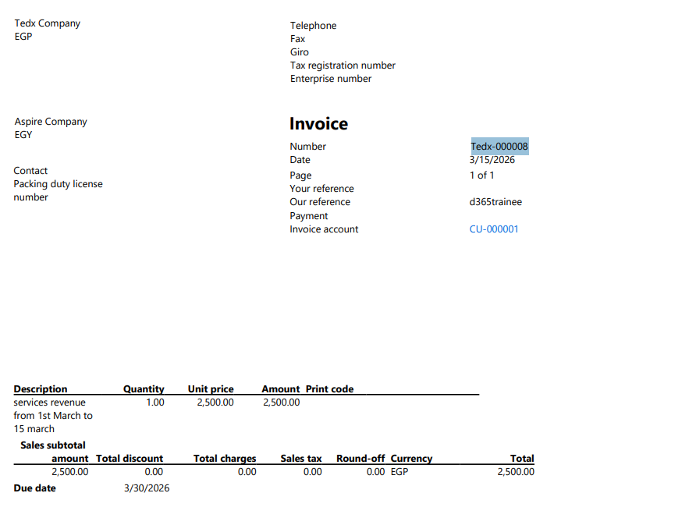
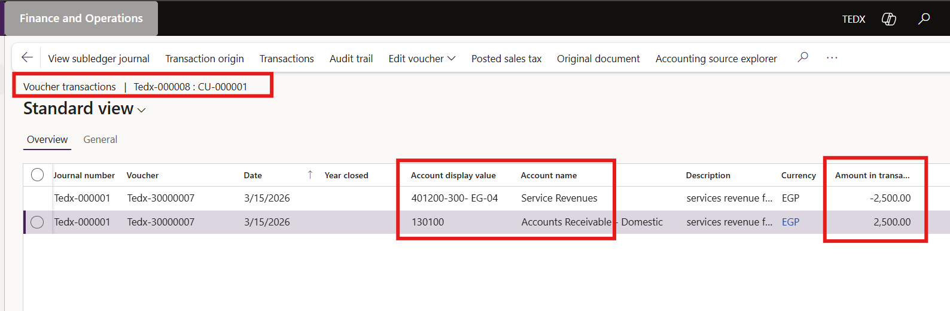

Customer Payment
Navigate to:
Accounts receivable → Payments → Customer payment journal
- Click New
- Select Journal Name
- Click Lines
Fill in:
- Account Type: Customer
- Account
- Amount
- Payment Method
- Click Post
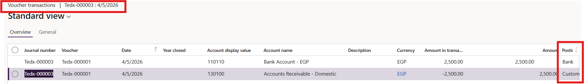

Settlement
Navigate to:
Accounts receivable → Customers → All customers
- Select customers.
- Click Transactions
- Select Invoice & Payment
- Click Settle Transactions
- Click OK
📸 Insert Screenshot Here

Customer Aging Report
Navigate to:
Accounts receivable → Inquiries and reports → Customer aging
- Select parameters
- Click OK
